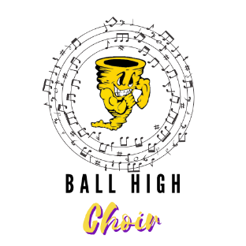
Ball High choir Booster club
The Ball High Choir Booster Club will be a vital aspect of the growth of the BHS Choir Program. The Booster will serve as a support to the Director, Program, Administration, and more importantly, the students. They will do so by:
- Promoting and supporting the Ball High Choir in achieving its fullest potential;
- Aiding in carrying out the policies initiated and formulated by the Director and Administration;
- Acting as an advocate for the students of the Ball High Choir Program;
- Fostering and maintaining a high degree of enthusiasm and spirit within the Ball High Choir Program;
- Assisting in boosting supplementary financial assistance to the Ball High Choir through Fundraising, Alumni outreach, performances, and more.

If you are interested in joining the Booster Club or would like more information regarding the club, please fill out the information below (in print). Mr. Menifee will reach out via email and discuss times to meet with Boosters to move forward for a great school year! If you have any questions regarding the Booster Club, you can email Mr. Menifee at larrianmenifee@gisd.org.

Name: ____________________________________________________
Email: _____________________________________________________
Cell: _______________________________________________________

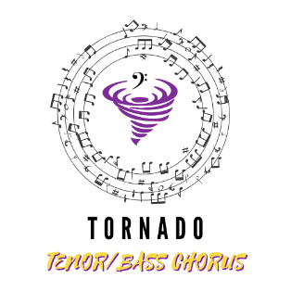
If you would like to join our Booster ‘remind’ for updates, text the code “@boostbhs” to the number 81010

